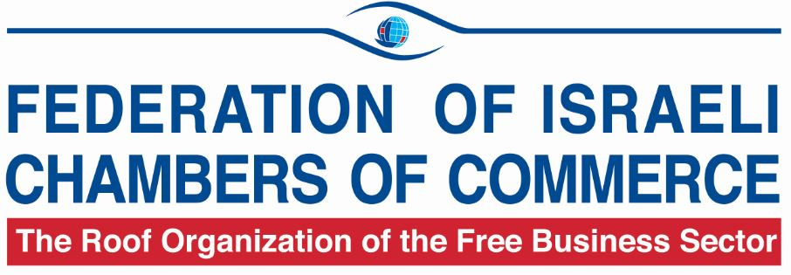

84 Hahashmonaim St. Tel-Aviv 67132, Israel
Tel: 972-3-563 1020, Fax: 972-3-561 9027
E-mail: chamber@chamber.org.il :http//www.chamber.org.il

BUSINESS OPPORTUNITIES FROM ISRAEL

Company Name | IMS - Inventory Management Solutions
Contact Person | Ms. Yonat Keren, International Relations Division, FICC
Telephone No. | 972-3-5631020
Fax No. | 972-3-5619027
E-Mail: | yonatk@chamber.org.il
Website | www.utiims.com
Year of Establishment | 2004
No. of Employees | 100
Summary of offer: | Services/Cooperation - Inventory Management; Procurement Management; Sourcing
Description of offer | MS provides services to supply chain management and procurement.  These are adapted according to our client's needs to ensure maximal savings.  Our 3 major models are:  1. VMI - Inventory management  2. Supper supplier - Procurement management. Instead of hundreds of suppliers - 1 supplier and 1 invoice per month.  3. Sourcing - finding alternative sources to save money.  We are looking for potential clients such as manufacturer companies that seek to save money and time in their supply chain.
Target Countries: | Europe

Company Name | Latent Image Technology Ltd.
Contact Person | Ms. Yonat Keren, International Relations Division, FICC
Telephone No. | 972-3-5631020
Fax No. | 972-3-5619027
E-Mail | yonatk@chamber.org.il
Website | www.miragelit.com
Year of Establishment | 1997
No. of Employees | 15
Summary of offer | Export - Homeland Security and Anti counterfeiting
Description of offer | Our firm offers:  Development, production and marketing of advanced anti- counterfeiting solutions. The Company's solutions are mainly targeted to official documents such as ID's, Passports, Driving License, Vehicle Registration, Tax Stamps for Tobacco, Alcohol and other products, Bank Guarantees, Warranty Certificates, and others. Recently the Company has been awarded a very large project for supplying the security features to 5 billion tobacco stamps per year. In the first year of application the revenues of taxes on stamps have increased by 33% due to the mitigation of illicit trade.  Our Company has a large variety of solutions that can be customized according to the customers' requirements.
Potential Partners | National printers; official authorities, such as Ministry of Finance, Ministry of Transportation, Ministry of Health, etc.
Target Countries | Eastern Europe; Latin America; Africa; Asia.

Company Name | Trade Dory International Relations Ltd.
Contact Person | Ms. Yonat Keren, International Relations Division, FICC
Telephone No. | 972-3-5631020
Fax No. | 972-3-5619027
E-Mail | yonatk@chamber.org.il
Website | www.tradedory.com
Summary of offer | Business Services to foreign companies
Description of Offer | Our company specializes in assisting foreign companies to do business in Israel.  One of our advantages is the ability to provide business services in Israel and provide business development services to neighboring countries.  Our company has extensive business relationships worldwide.
Target Countries | Worldwide.

Company Name | MILEGA LTD.
Contact Person | Ms. Yonat Keren, International Relations Division, FICC
Telephone No. | 972-3-5631020
Fax No. | 972-3-5619027
E-Mail | yonatk@chamber.org.il
Website | www.milega.info  www.milega.co.il  www.yogibo.com
Year of Establishment | 1994
No. of Employees | 66
Summary of offer | Joint Venture Partner/Cooperation/Franchise  Home Design
Description of offer | Milega develops and produces top notch products for home design. Our flag product is the "Yogipoof" - Bean bags, based on the special formula that Milega developed. The serial of Bean bags are produced in different sizes, colors for various purposes, based on consumer insights.  Milega is a solid brand, distributing its products in a variety of stores in Israel.  The products are also distributed worldwide: US, Canada, Panama, Holland, Australia, New Zealand and France.  Milega brand consists of 6 categories: Yogipoof, Yogi baby, Linens, Indoor and Outdoor furniture.  Milega is a solid brand looking for international partners in order to deliver and share the experience and knowledge in this area with all our support all the way!
Target Countries | Spain, Bulgaria, Czech Republic, UK, Germany, Italy, Austria, Switzerland.

